
press release
(English translation)

IEG, AT ECOMONDO 2025, FOCUS ON INTERNATIONALITY:
THE GLOBAL FUTURE OF THE ECOLOGICAL TRANSITION IS HERE

Europe and the Mediterranean basin’s event of reference for the green, blue and circular economy, from 4 to 7 November at Rimini Expo Center (Italy)

30 halls and 166,000 m² of exhibition space, delegations from all over the world and a conference program on global challenges

● Focus on AI and digitalization, recycling, eco-design, satellite monitoring and industrial decarbonization; the Innovation District and Green Jobs & Skills

● The return of SAL.VE, in collaboration with ANFIA

Rimini (Italy), 19 May 2025 – From 4 to 7 November, Ecomondo, the Italian Exhibition Group (IEG) event of reference in Europe and the Mediterranean basin for the green, blue and circular economy, will be back at Rimini Expo Center. Combining business growth with environmental and social protection through the adoption of ethical and inclusive development models is a requirement for which Ecomondo can act as a go-between by promoting dialogue between industries, institutions and the world of research. The 28th edition of Ecomondo, the most ambitious ever, will strengthen its international vocation and consolidate its role as a global circular economy and ecological transition platform and hub.
Target countries in 2025 will be Germany, Spain, Poland, Serbia, Turkey and the Netherlands, as well as the North African countries of Egypt, Morocco, Algeria, Tunisia and the Middle East.
Ecomondo will be joined in 2025 by SAL.VE, the biennial Exhibition of Ecological Vehicles, in partnership with ANFIA.
And the States General of the Green Economy, organized by the Sustainable Development Foundation, promoted by the National Council for the Green Economy in collaboration with the Ministry for the Environment and Energy Security and with the patronage of the European Commission, will also be back.
“Ecomondo 2025,” explains Alessandra Astolfi, IEG’s Global Exhibition Director of the Green & Technology Division, “will occupy 30 halls covering 166,000 square meters of exhibition space. Due to synergy with the Italian Trade Agency and Ministry of Foreign Affairs and International Cooperation (MAECI), delegations from all over the world are expected to attend in collaboration with 80 international sector associations, confirming the event’s role as Europe’s leading appointment on the latest innovative models of circular economy.”
To make it easier for European and international visitors to attend the event, new direct flight connections to Rimini from Munich and Rome, organized by IEG and operated by LuxWing, will be in service from 4 to 7 November, favoring the participation of international operators in our territory.
The event confirms its global networking role thanks also to the recently concluded editions of Ecomondo Mexico and Ecomondo China – CDEPE, and the imminent appointment in Italy with the Green Med Expo & Symposium (Naples, 28-30 May 2025), all of which will be staged again in 2026.

THEMED AREAS, FOCUSES AND VERTICAL DISTRICTS
Ecomondo will feature six themed macro areas – Waste as Resource, Water Cycle & Blue Economy, Sites & Soil Restoration, Bioenergy & Agricolture, Earth Observation and Environmental Monitoring and Circular and Regenerative Bio-Economy.
Other focuses will be the Blue Economy District for marine ecosystems, Circular Healthy City for circular and healthy cities, the Paper District for sustainable paper design, the Textile District for ethical fashion and the Trenchless District for No Dig technologies. The Innovation District will be the center of innovation with an enhanced Start-Up & Scale-Up area and a focus on Green Jobs & Skills. Moreover, the Lorenzo Cagnoni Award for Green Innovation will reward the most revolutionary technologies in the various exhibition sectors.
Advanced recycling of strategic raw materials, eco-design and new packaging solutions to reduce the impact along the entire supply chain without compromising functionality, artificial intelligence and digitalization to accelerate the ecological transition, new technologies for satellite monitoring to counter the impacts of climate change and industrial decarbonization with special focus on textiles, energy, WEEE and the construction industry, will also be among the themes at Ecomondo 2025.

A TECHNOLOGY-INTENSIVE CONFERENCE PROGRAMME
Ecomondo will accompany the exhibition area with a packed calendar of conferences, seminars and round tables, organized by its Technical-Scientific Committee, with in-depth talks on regulatory aspects, policies and regulations, also in light of the Next Generation EU plan, as well as ecosystem restoration, the blue economy and the regenerative economy, AI, Digital Twin and new technologies, predictive resource management, bioenergy and satellite monitoring of environmental transformations and land management, finance, communication and the circular economy and ecological transition in Africa and the Mediterranean basin, focusing, among other things, on the Mattei Plan.

INSTITUTIONAL PARTNERS
Ecomondo 2025 is organized by Italian Exhibition Group with the collaboration of: the European Commission; the Ministry for the Environment and Energy Security; the Ministry for Enterprise and Made in Italy; ITA - Italian Trade & Investment Agency; the Emilia-Romagna Region; the Municipality of Rimini; ANCI (National Association of Italian Municipalities); ANFIA (National Association of the Automotive Industry); ART-ER; CIB (Italian Biogas Consortium); CIC (Italian Composters Consortium); CONAI (National Packaging Consortium); ENEA; Assoambiente; Foundation for Sustainable Development; ISPRA (Institute for Environmental Protection and Research); Legambiente; UNICIRCULAR (Assoambiente section); UNACEA (Italian Trade Association for Construction Equipment & Attachments); UTILITALIA; CIHEAM (International Center For Advanced Mediterranean Agronomic Studies) CBE JU (Circular Bio-based Europe Joint Undertaking); EBA (European Biogas Association); European Environment Agency; ISWA (International Solid Waste Association); WBA (World Biogas Association); Water Europe.

ABOUT ECOMONDO 2025
Event: International trade show; Organization: Italian Exhibition Group S.p.A.; Frequency: annual; Edition: 28th; Dates: 4-7 November 2025; mail: ecomondo@iegexpo.it; Website: www.ecomondo.com; Facebook: www.facebook.com/EcomondoRimini; LinkedIn: https://www.linkedin.com/company/ecomondo-the-green-technologies-expo/

PRESS CONTACT IEG/ECOMONDO 2025
head of media relation & corporate communication: Elisabetta Vitali; press office manager: Pierfrancesco Bellini; international press office coordinator: Silvia Giorgi; media@iegexpo.it

MEDIA AGENCY IEG/ECOMONDO: Smartitaly Communications
Edoardo Chiesa, +39 333 8744340 - e.chiesa@smartitaly.it; Paola Gervasio, +39 346 6064272 - p.gervasio@smartitaly.it; Francesca Pericolo, +39 327 9861860 - f.pericolo@smartitaly.it; Foreign Press - Andrea Indiano, +39 349 3232557 – a.indiano@smartitaly.it

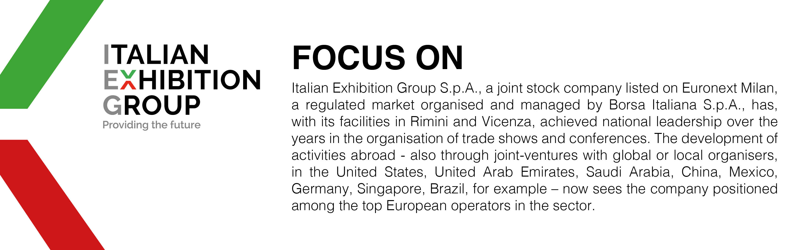

This press release contains forecast elements and estimates that reflect the management’s current opinions (“forward-looking statements”), particularly regarding future management performance, realization of investments, cash flow trends and the evolution of the financial structure. For their very nature, forward-looking statements have a component of risk and uncertainty, as they depend on the occurrence of future events. The effective results may differ (even significantly) from those announced, due to numerous factors, including, only by way of example: food service market and tourist flow trends in Italy, gold and jewellery market trends, green economy market trends; the evolution of raw material prices; general macroeconomic conditions; geopolitical factors and evolutions in the legislative framework. Moreover, the information contained in this release does not claim to be complete, and has not been verified by independent third parties. Forecasts, estimates and objectives contained herein are based on the information available to the Company as at the date of this release.

